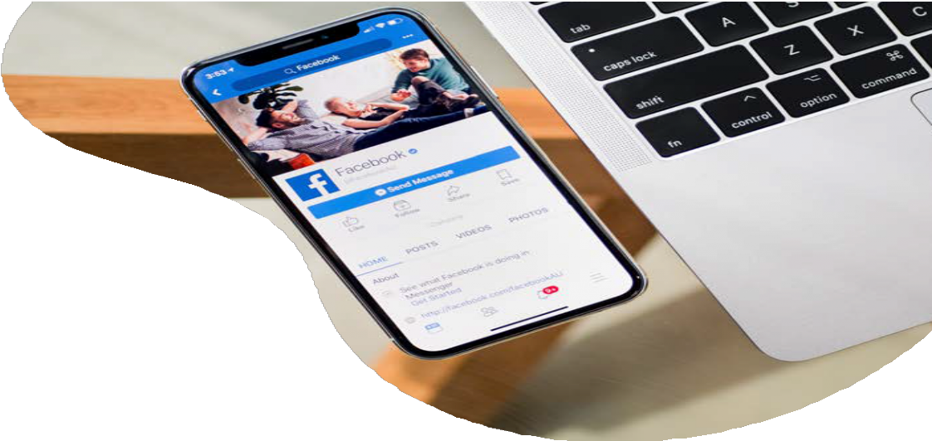O V E R V I E W

F A C E B O O K & I N S T A G R A M
L e v e r a g e t h e p o w e r o f t w o b i l l i o n m o n t h l y F a c e b o o k u s e r s a n d 5 0 0 m i l l i o n d a i l y
I n s t a g r a m u s e r s w i t h s o m e o f t h e m o s t
p r e c i s e a u d i e n c e t a r g e t i n g a v a i l a b l e t o d a y .

1 of every 5 minutes people in the US spend on mobile is on Facebook or Instagram. 93% of marketers use Facebook advertising regularly.

A D T Y P E S

Lead Generation
Capture those ready to convert from the platform they love best. Facebook Lead Generation Ads utilize the same precise targeting options as traditional Facebook ads, but adds the platform’s incredible ability to persuade people to act.

Image
Use beautiful images to convey your message.

Video
Tell your story with sight, sound and motion.

Carousel
Show multiple images or videos in a single ad. The carousel format allows you to showcase up to 10 images or videos within a single ad, each with its own link. With more creative space within an ad, you can highlight different products, showcase specific details about one product, service or promotion, or tell a story about your brand that develops across each carousel card.

Collection
Collection is an ad format that makes it easier for people to discover, browse and purchase products and services from their mobile device in a visual and immersive way. A Collection experience typically includes a cover image or video followed by several product images.

Messenger
Help people start conversations with your business.

* Available ad formats vary based on ad spend.

Recommended Image Size: 1200x628pixels Recommended Image Ratio:1.91:1. See full specs at https://go.ui.marketing/product-specs

What is the advertiser selling on Facebook?
F A C E B O O K
F O R M
P l e a s e c o m p l e t e t h e i n f o r m a t i o n b e l o w :
What type of business is this?

Are you Admin to the page? If not, who is the Admin of your FB page?

Who is the FB page owner at your company?

What is the FB Business Page URL?

Will this FB campaign be targeting Credit, Employment or Housing targets? If so, please confirm the exact targeting requested.
*Disclaimer that includes the limited targeting available when a client wants to target Credit, Employment or Housing targets.

Is this FB campaign for a Political advertiser (i.e. Social Issues, Elections or Politics)? If so, we will require the advertiser Get Authorized to Run Ads About Social Issues, Elections or Politics and complete the Authorization Process based on their country. We will require FB Page Admin Access in order to run a Facebook campaign.

Will you be requiring a FB Pixel to be built? Y/N *Disclaimer on how the best practice is for the client to create the pixel so it lives within their page

If a FB Pixel is needed, we will require Domain Verification to be completed and confirmed prior to the FB campaign going live.

You as the client will then need to place the FB pixel and share the pixel with AdCellerant (needs to be white-labeled).

You as the client will then need to Configure Events to Use Aggregated Event Measurement prior to the campaign going live.

