O V E R V I E W D E T A I L S

It is easy to introduce non-skippable, brand-safe programmatic audio advertising to your local marketing campaigns. Programmatic audio allows you to choose inventory by location and hour of day to reach your target audience.

It also allows you to run traditional radio campaigns while also receiving the benefit of real-time decision reporting, conversion metrics, cross-device targeting, and omnichannel optimization.
Targeted, high-impact messaging.

Target audio ads to relevant geographies and time slots to hone in on valuable prospects

Reporting tracks metrics including completion rate, clicks, and conversions so you understand how audio works with other channels & strategies

Include a companion banner that clicks through to a landing page on most inventory

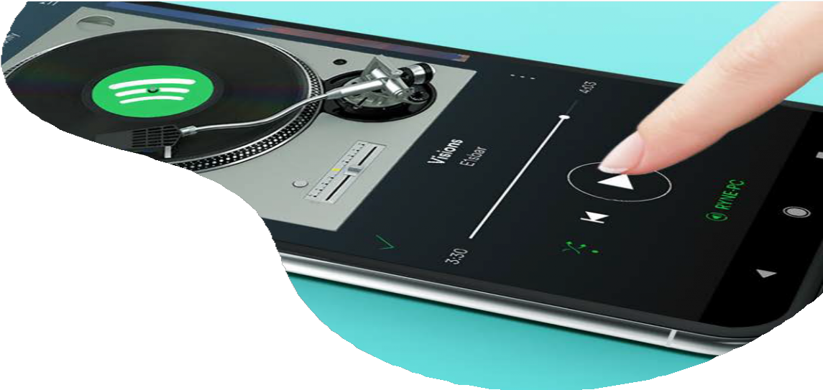
S T R E A M I N G
A U D I O
R e a c h y o u r t a r g e t a u d i e n c e w i t h
p r o g r a m m a t i c s t r e a m i n g r a d i o a d v e r t i s i n g .
M u s i c i s e v e r y w h e r e i n t o d a y ’ s s o c i e t y . I t i s w i t h
u s w h e n w e g e t u p i n t h e m o r n i n g , g o t o w o r k , s i t a t o u r d e s k s , g o t o t h e g y m , w h i l e w e e a t , a n d
e v e r y w h e r e i n - b e t w e e n . I s t h e r e a b e t t e r w a y t o t o u c h y o u r t a r g e t a u d i e n c e ?
Retarget users who have reached the midpoint or end of your audio ad

The US has 224 million digital audio listeners, with Spotify making up 83.1 million of those users

Consumers carry these channels with them at all times via their mobile device revolutionizing audio advertising, allowing marketers to reach consumers anywhere they are at any time they’re listening.
File types can include MP3, M4A, WAV with a bitrate of 160 kps. Creative lengths should be 15 or 30 seconds. https://go.ui.marketing/product-specs

