D E V I C E I D & G E O - F E N C I N G

M o b i l e p h o n e s p r o v i d e a u n i q u e v i e w
i n t o u s e r b e h a v i o r s , f r e q u e n t l y v i s i t e d l o c a t i o n s , h o m e , w o r k , h a b i t s ,
i n t e r e s t a n d m u c h m o r e .

O V E R V I E W H O W T O U S E

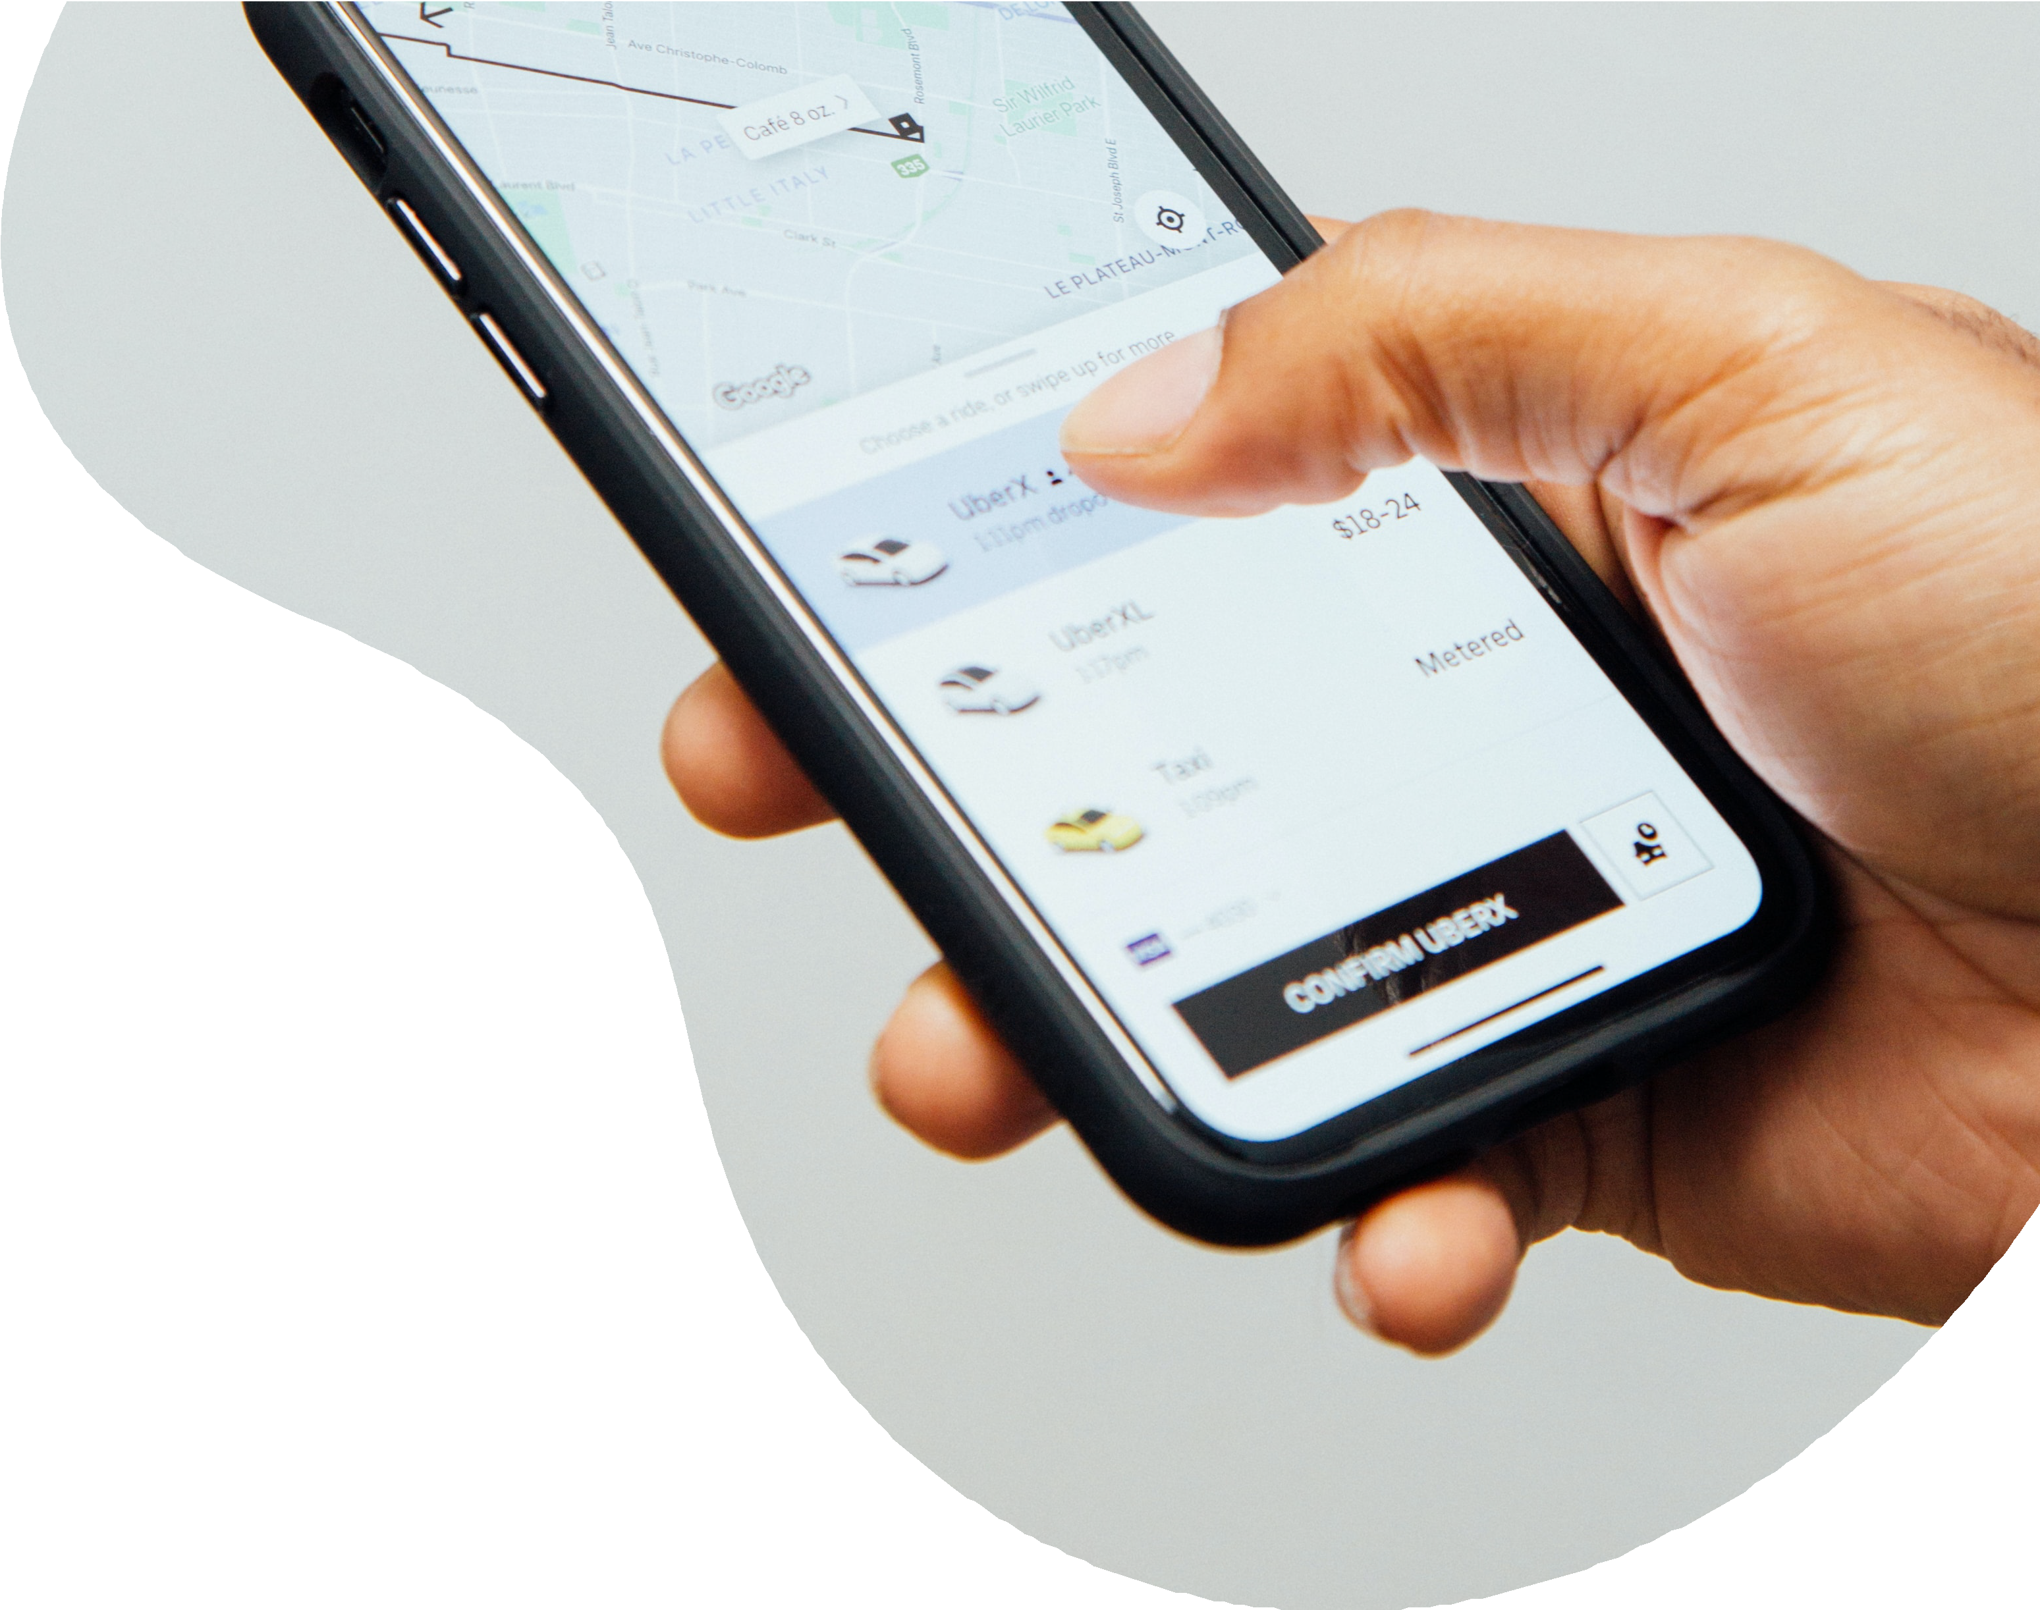
Every mobile phone has a unique device ID number that is anonymously associated with the carrier of the device. Device ID Targeting and Geo-Fencing takes advantage of that by monitoring the location information associated with each device. This information is beamed to the cloud and made available for marketers to leverage and ultimately target consumers or their devices based on where they have been, where they live, and much more.

B E N E F I T S & S T A T S

Benefits
Device ID allows advertisers to capitalize on precise targeting, increased engagement, better efficiency, boosted ROI/Conversions, no reliance on cookie data, and Point of Interest Attribution.

Stats
68% of people check their phones within 15 minutes of waking up

150x - number of times the average person checks their phone every day

87% of people keep their phone by their side day and night

91% of people turn to their phones for ideas while in the middle of tasks
Once all of the locations associated with the ideal consumer behavior are identified, a polygon is drawn around each location. Using historical data, we're able to capture devices as far back as 6 months ago and as recently as 3 days ago.

An Audience Insight Report is then created, which is a demographic report for the users who have been identified within the polygon. These reports tell us the consumers' basic demographic data, visitor
frequency, household income, and much more.

Once the programmatic campaign is live, Device IDs are collected at specific Points of Interest (POIs), usually the business owner's brick and mortar locations during and after the campaign flight dates. This same form of data collection is also used to track in-store foot traffic, and can be tied back to consumer addresses or specific store sales.

