M I C R O P R O X I M I T Y

T a r g e t p e o p l e o n t h e i r m o b i l e d e v i c e b a s e d o n w h e r e t h e y a r e i n r e a l t i m e .

W o u l d y o u l i k e t o r e a c h p e o p l e v i s i t i n g y o u r c o m p e t i t o r s r i g h t n o w ?
M i c r o p r o x i m i t y a l l o w s y o u t o d o t h a t .

D E T A I L S L O C A T I O N S P E C I F I C
By leveraging and buying the most accurate location data
available today we can reach people at a specific location

or radius in real time.

50% of impressions have location data of insufficient quality for precise targeting. We only target consumers where we have enough information to pinpoint them in a specific location. Many providers target users with insufficient data, wasting ad dollars.

The best thing about Microproximity is that distance is not the only determinant. Other factors you should consider when setting up your campaign to drive the most relevant leads include:
We use decimal place precision, allowing us to accurately
target small venues with precision.

5 Decimal Places = <1 meter: Accurately located inside a small venue or coffee shop.

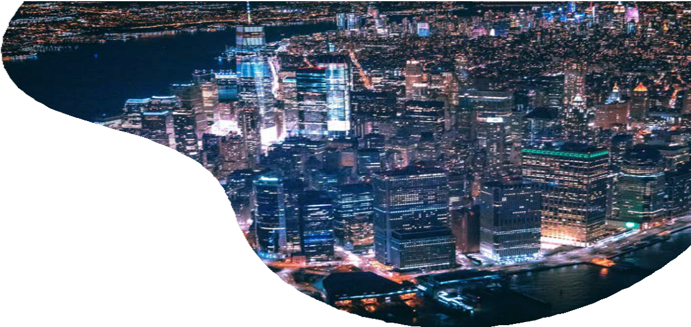
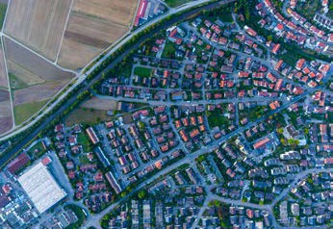Location targeting

Recommended ad sizes: 728x90, 300x250, 320x50, 160x600, 300x600 in a jpeg or gif format. See full specs at https://go.ui.marketing/product-specs
Target consumers when they're at specific locations, including offices, stores, or streets.
Conquest targeting
Target consumers while they are visiting your competitor's locations.
Area targeting
Target customers in the area or ask them to come back when they're just around the corner.
Activity and interest targeting
Reach customers based on the category of their current location like restaurants, bars or coffee shops.

The bottom line; high quality data reaches the right people, low quality data wastes money.

