Native advertising aligns itself with the look and feel of its environment. Native is essentially the modern advertorial utilizing more robust content targeting.

Aesthetics: Formatted like its surroundings
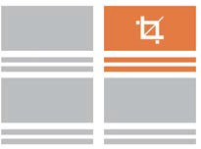

Location: Located within the feed of content
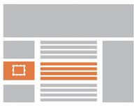

Value: Provides helpful information

Direct Response
Drive sales from your native ad campaigns with increased brand recall and likelihood to buy.

Engagement
Place your content front and center on the world’s best sites to get higher engagement.

Awareness
When using a brand lift study, native ads drive 3x higher brand awareness and purchase intent.

Reach 92% of the online population and 86% of mobile users. Native advertising drives Millennials to make purchases.

It's recommended to send 5-10 images for consideration. Recommended images requirement: 1200x1200 pixels with a file size under 1 MB. See full specs at https://go.ui.marketing/product-specs

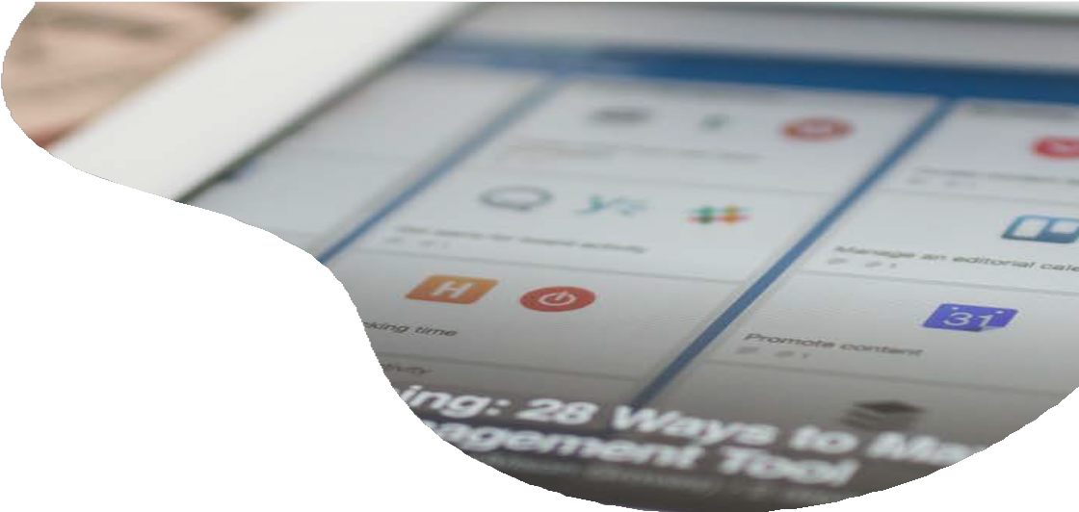
N A T I V E
A D V E R T I S I N G
P r o g r a m m a t i c N a t i v e A d v e r t i s i n g s e a m l e s s l y
i n t e g r a t e s a b r a n d ’ s m o s t e n g a g i n g i m a g e s a n d c o n t e n t i n t o c o n t e x t u a l l y r e l e v a n t e d i t o r i a l
u s i n g a s i n g l e c r e a t i v e t h a t d y n a m i c a l l y a d a p t s
t o m a t c h f o n t a n d f o r m a t .
D E T A I L S
B E N E F I T S
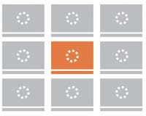

Content targeting options include:
Auto, Business, Entertainment, Food, Home, Men’s Fashion, News, Sports, Travel, Women’s Fashion and Technology.

