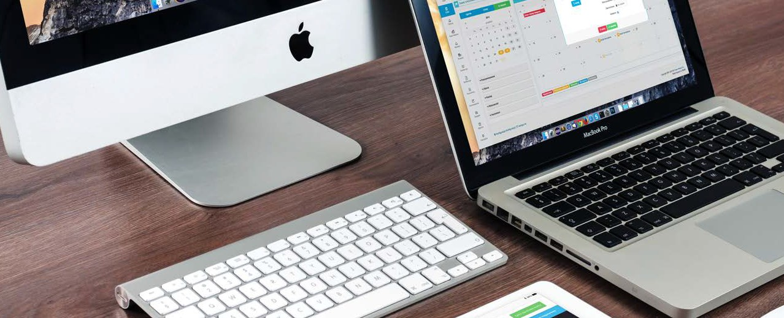
P R O D U C T I N F O
Website Development
Have a new website built – the way you want your business to be represented – by real web professionals supported by cutting-edge development and security technology.
WEB DEV STATS
for businesses:

42%
of people will leave a website because of poor functionality.

50%
of consumers believe that website design is crucial to a business’s overall brand.

60%
of consumers rate usability as an important design characteristic for an online shop.

85%
of web designers said that crowded web design was the most common mistake by small businesses.

According to Behaviour and Information Technology, it takes 0.05 seconds for users to create an opinion about your website. Take control of their first impression and make changes to the content, look, and feel seamlessly in our simple-to-use interface.
Professionally-designed
Own your own domain
Easily add and edit content anytime Fully secure website (HTTPs)

WHY CHOOSE US?
Ownership
Many website providers will hold your content hostage so that it's difficult to cut ties with them. If you cancel with us, we will always allow you to take what is rightfully yours.

Our Team
Many competitors will build you a website with software only. This often leaves you with a website that has limited functionality, lacks SEO, has poor ease of use, and ultimately doesn’t look ‘right.’ Working with us, your site will be built by an expert web developer with decades of experience.

Flexibility
We have a number of website solutions for you. Whether you need an entry- level website at a low cost or a custom WordPress solution with additional capabilities, we have an option right for you and your business.

