D E T A I L S C A M P A I G N T E A M

Our team adheres to a thorough setup process for each campaign to ensure it is customized to your business and optimized for results.

Professional ad development and optimization Rigorous keyword analysis and optimization Competitor analysis and competitor conquesting Bid and budget management strategy
Campaign optimization strategy including
A, B & C ad copy testing, ad group optimization, and more
Dedicated team of Google Ads and Bing certified professionals
Every campaign is assigned a dedicated campaign management team of experienced and certified professionals.

Conversion tracking and ROI focused
PPC campaigns are powerful because they are able to track conversions and track ROI. We track all applicable conversions through Google Analytics and our proprietary reporting platform Ui.Marketing.

Call tracking
We track, record, and provide insight into each phone call your business receives from our campaigns.

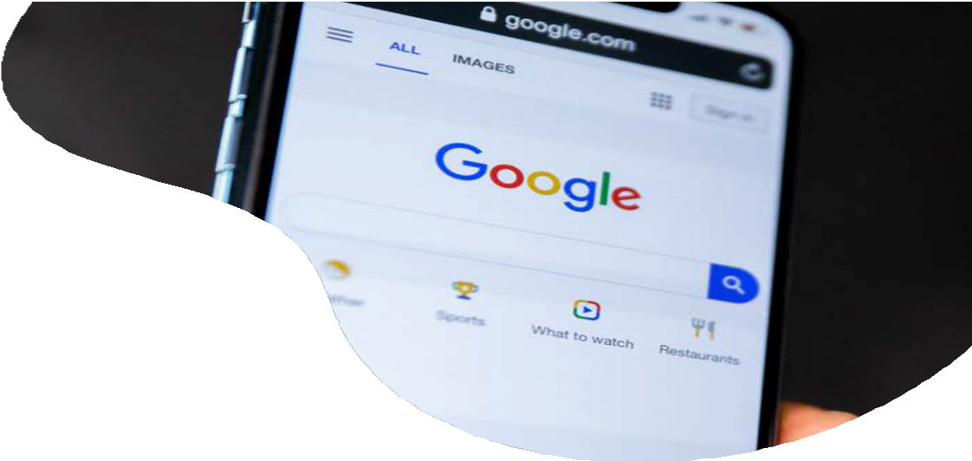
S E A R C H
E N G I N E
M A R K E T I N G ( S E M )
O u r t e a m o f G o o g l e A d s c e r t i f i e d
p r o f e s s i o n a l s f o l l o w a l l o f G o o g l e ’ s B e s t p r a c t i c e s a n d a r e e n d o r s e d b y G o o g l e .
O u r c u s t o m a p p r o a c h s e p a r a t e s o u r t e a m f r o m t h e r e s t o f t h e p r o v i d e r s i n t h e
m a r k e t e n s u r i n g y o u r s o l u t i o n i s c u s t o m t o y o u r n e e d s .

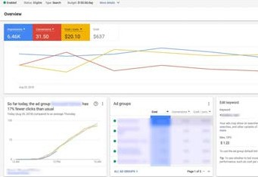See full specifications at https://go.ui.marketing/product-specs

